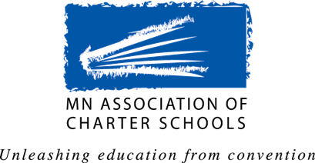
MACS Government Affairs Committee

Request for legislative proposals

The Public Policy Agenda
The Association’s Public Policy Agenda is a statement of the policy positions adopted every biennium by the membership. In developing the Agenda the Association seeks input from the charter school community on what issues should be part of that Agenda by asking for proposals from charter school boards, school administrators, teacher or staff members, authorizers, associate members, and other interested parties.

Proposals submitted are reviewed and considered by the Government Affairs Committee. After their consideration the Committee makes recommendations to the MACS Board of Directors for approval, and then the proposed Agenda is sent to member schools for ratification.

Deadlines for Submission of Legislative Proposals
1st Deadline – Friday, June 24, 2016
Final Deadline – Friday, September 30, 2016

Contact Information
Name: _
School/Organization:
Position/Title: _
Phone: _
Email: _

Legislative Proposal Information
Please provide as much information as possible about the issue and the impact the proposal will have on charter schools in Minnesota. This information must be provided so the proposal can receive full consideration by the committee.

Topic/Issue:

Background Information:

Proposed Position/Solution:

Rationale for this Position/Solution:

