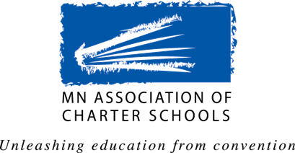
MACS Government Affairs Committee
legislative proposals for 2019 Session

The Public Policy Agenda
The Association’s Public Policy Agenda is a statement of the policy positions adopted every biennium by the membership. In developing the Agenda the Association seeks input from the entire charter school community by asking for proposals from charter school boards, school administrators, teacher or staff members, authorizers, associate members, and other interested parties. Proposals submitted are reviewed and considered by the Government Affairs Committee. The Committee’s recommendations are sent to the MACS Board of Directors for approval, and then the proposed Agenda is sent to member schools for ratification.

Submission of Legislative Proposals for 2019 Legislative Session
In order for your proposal to receive consideration by the Government Affairs Committee please submit your proposal by Friday, August 3, 2018.

Legislative Proposal Information
Please provide as much information as possible about the issue and the impact the proposal will have on charter schools in Minnesota. This information must be provided so the proposal can receive full consideration by the committee.

Topic/Issue:

Background Information:

Proposed Position/Solution:

Rationale for this Position/Solution:

Contact Information
Name: _
School/Organization:
Position/Title: _
Phone: _
Email: _

