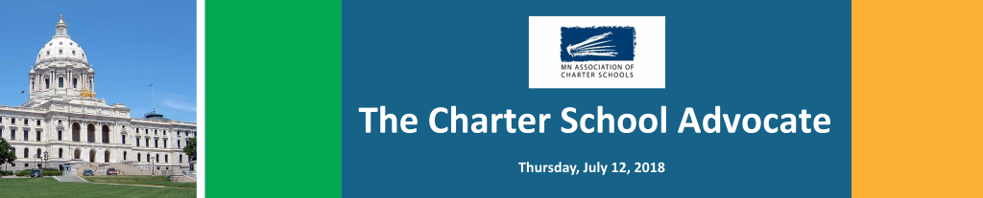
Good Morning,
The Association’s Government Affairs Committee met in late June and continued its work on defining the specific positions that will flesh out our “Agenda to Fulfill the Promise” that the Association will outline our legislative goals for the next biennium and beyond.
TODAY, we are sharing a DRAFT of the section of the Agenda that deals with Charter School Facilities. We would appreciate any feedback or suggestions.
2] A RATIONAL POLICY APPROACH FOR CHARTER SCHOOL FACILITIES
“While it may have made sense when the charter school law was enacted that charter schools, (which were an experiment at the time) to not allow directly own buildings using public funds, that policy 27 years later is illogical, irrational, and a fiscally irresponsible way to provide for charter school facilities.
The question needs to be asked: Why do we have still have an illogical, irrational, and fiscally irresponsible system for providing facilities for chartered public schools?
The Answer: There is no reason.
Statement of Beliefs

Given that a school facility can enhance or detract from the ability to learn, all children, including children who attend public charter schools, have a right to expect that the school facility they attend is safe, healthy, and conducive to learning.

Since 1991, when the charter school law was enacted, the public policy of the state of Minnesota has been that charter schools may not directly own school facilities using public funds. While the state has provided charter schools with lease aid, lease costs must be supplemented by funding from a school’s general fund.

As a result of these policies, some charter schools have created non-profit affiliated building companies to purchase or build a facility, while other schools are often housed in facilities, while safe, are often not the most conducive to the learning program or the needs of students. Neither of these arrangements are the best deal for either students or the state.

Therefore, we support legislation to:
- Allow direct ownership of facilities by charter schools that meet appropriate criteria, including a record of effective governance, sound financial management, effective business practices, and a plan for a sustainable future.

- Establish a Minnesota Charter School Facilities Authority empowered to issue bonds for qualifying charter schools to purchase, purchase and renovate, or construct facilities directly owned by the school.

- Transfer the ownership of school facilities currently held by a school’s non-profit affiliated building company to the school non-profit corporation when the mortgage or bonds of that affiliated company are either renegotiated or redeemed, so that if a school closes after that point, the facility is deemed school property and a public asset.

- Restructure “Lease Aid” revenue to be “Facilities Aid” revenue with a differentiated rate for “Facility Lease Aid” for all schools that lease or have a mortgage, and “Facility Asset Preservation Aid” for schools that own a building without any debt on the facility.

- Allow facility related health and safety facility requirements as allowable expenses in the definition of Facilities Lease Aid and Facility Asset Preservation

- Limit the amount a school district or other public entity may charge for leasing a facility to a charter school to the “Facility Asset Preservation Aid” revenue rate if the public facility is without debt.

- Provide leverage to charter schools in negotiating leases by allowing charter schools to include health and safety requirements in lease costs eligible under Facilities Aid Revenue, given that charter schools must comply with all federal, state and local health and safety laws and regulations, but do not possess the ability to levy for Health and Safety as traditional districts.

- Exempt property a charter school leases from a property owner from real estate taxes on the portion of the property the school leases, in the same manner as property leased by a traditional district is exempt.

- Clarify that the Commissioner approves or disapproves the Lease Aid application, not the actual lease(s) of a school.

- Tie the per pupil amount of Lease (Facilities) Aid amount to 20 percent of the general revenue formula.”

Again, this is a draft, please send your feedback or suggestions to me at: eugene@mncharterschools.org.

MACS – MACSA Public Policy Meeting
Last week Mary Apuli, Chair of the MACS Government Affairs Committee and I met with Stephanie Olsen, Chair of the MACSA Legislative Committee, Larry McKenzie, Chair of MACSA and Emily Edstrom, a member of the MACSA Committee, from Pillsbury United to discuss a series of public policy issues to see where we can find agreement in preparation for the 2019 legislative session.
The Topics Discussed and Action Steps.
1] Authorizer Role/Responsibilities – discussed the various perspectives and motivations underlying the need for defining the role/responsibilities of authorizers.
Action – agreed to work on developing language that both organizations can support - using the 2017 MACS and MACSA drafts as a point of reference.
2] Transfer of Authorizers – discussed the perspectives of schools and authorizers, the philosophical issue of choice. Agreed that both schools and authorizers should be on equal playing field in being able to end relationship without reason.
Action – agreed to work on developing language that includes the option that - if the school is in good standing - both the school and/or authorizer can notify the other without reason to end the relationship upon adequate notice at the end of a contract.
In addition to these two topics where there was agreement on the next steps, the group also had a wide ranging discussion about 3] Authorizer Fees, 4] MAPES and 5] Authorizer Capacity. We will share more about those discussions as we move forward about these issues.

FEDERAL CHARTER SCHOOL PROGRAM GRANT - MDE PERFORMANCE MEASURES
As you know, late last year Minnesota was awarded a new Federal Charter School Program Grant of $38 million for 2018-2022. In that grant MDE outlined a series of Performance Measures including:
- 200 charter schools by 2022
- A total of 55 grants by 2022 – startup and expansion grants
- A significant increase in charter school enrollment from current 6% to 16% of all students
- Identification of core competencies for charter school leaders
- 50% of charter schools participating in a school leadership pilot program
- Credential (school leadership) program handbook by 2022
- 85% of authorizers annually attend grant-funded educational opportunities to increase their knowledge and capacity
- Annual increase in reading and math proficiency of 4th and 8th grade charter school students (1-2% each year)
Comment: These performance measures were developed by MDE, and it is not clear what the Department’s plan is to achieve some of these measures (e.g. enrollment or student proficiency)

FEDERAL COURT DECISION – A RIGHT TO LITERACY?
A federal court in Michigan has ruled that there is NOT a constitutional right to literacy under the United States Constitution.
In the case, Gary B v Synder the court ruled the even though there was “well documented problems of vermin-filled classrooms, outdated textbooks, and dysfunctional leadership in Detroit,” the Constitution does not guarantee literacy.
The court indicated sympathy for the plaintiffs but the court said the question was, “Does the due process clause of the 14th amendment demand that a state affirmatively provide each child with a defined, minimum level of education by which the child can attain literacy?”
The court ruled that the answer to the question is NO. The plaintiffs have announced that they intend to appeal the decision.

REMEMBER TO ENCOURAGE EVERYONE TO VOTE. PRIMARY – TUESDAY, AUGUST 14TH

