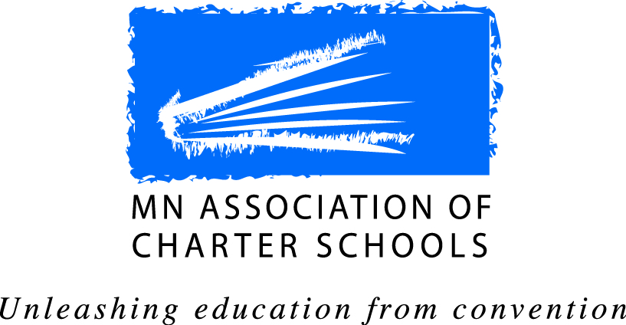
Individual - Associate
Membership Application

Contact Information

Name: _
Email: _
Address: State: Zip Code: _
Home Phone: Work Phone: Cell Phone: _ School Affiliation (if any): _
Individual-Associate Members and MACS:
Through individual membership, you can show your support for MACS’ service to the MN charter school community. Your contribution helps promote innovation, quality, choice, and accountability in public education by promoting charter schools in Minnesota. In recognition of your contribution, you may:
- Attend MACS Annual Membership Meeting at member discounted rate;
- Support the Association’s advocacy efforts at the state;
- Stay informed on public policy issues;
- Participate in all Committees and Work Groups of the Association.

Receiving Communications from MACS:
As an Individual-Associate Member of MACS, you may choose to receive communications on a number of topics. Please place a check next to areas of interest.

I would like to receive The Charter School Advocate, the Association’s public policy newsletter

I would like to receive invitations to Assocation events

I would like to participate in the Association’s work.
Individual – Associate Membership Dues

Membership Dues $25

Individual-Associate Membership is for twelve months from the month in which you join.
Payment Information

Amount Enclosed: $25 (Make checks payable to: MN Association of Charter Schools)

Mail completed form and dues to:
Individual - Associate Membership
Minnesota Association of Charter Schools
161 St. Anthony Ave.
Suite 1000
St. Paul, MN 55103

