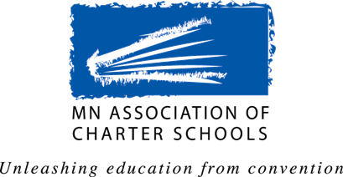
MACS Government Affairs Committee

legislative proposal Invitation

The Public Policy Agenda
The Association’s Public Policy Agenda is a statement of the positions adopted by the membership. In developing the Agenda the Association invites proposals from charter school boards, school administrators, teacher or staff members, authorizers, associate members, and other interested parties.

All proposals submitted are reviewed by the Government Affairs Committee. If the Committee makes recommendation relative to the proposal it is forwarded as part of the proposed agenda to the MACS Board of Directors for approval, and then the proposed agenda is sent to member schools for ratification. Proposals ratified by the members become the basis of the Association’s work at the Legislature

Deadline for Submission of Legislative Proposals
Proposals are accepted at any time, but for the proposal to be considered for the 2018 Agenda – the proposal must be submitted no later than FRIDAY, DECEMBER 1, 2017

Contact Information
Name: _
School/Organization:
Position/Title: _
Phone: _
Email: _

Legislative Proposal Information
Please provide as much information as possible about the issue and the impact the proposal will have on charter schools in Minnesota. This information must be provided so the proposal can receive full consideration by the committee.

Topic/Issue:

Background Information:

Proposed Position/Solution:

Rationale for this Position/Solution:

