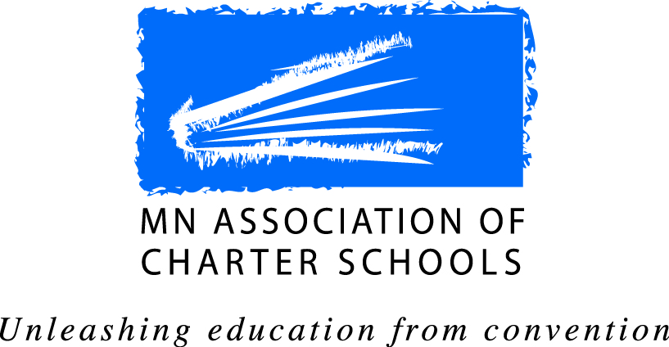
2021 MACS Board of Directors Nomination Form

Term of Office:
Eligible individuals – any school administrator of an operating charter school that is a member of the MN Association of Charter Schools. Only one (1) individual from a school is eligible to serve on the Board at any one time.
Four 2-year seats open
Term of Office: July 1, 2021 - June 30, 2023
An * indicates required fields.

Nominee Name *: Title/Position *:

Charter School *:

Number of Years at School *: Email *:

Work Phone Number *: Cell Phone Number:
*Please attach a photo of yourself in jpg or png format with this form.
Why do you want to serve on the MACS Board of Directors?*:

Please share any prior governing board experience*:

What experiences do you have advancing public school education, equity and choice?*:

Skills, talents or professional connections relevant to our Association’s work*:

What are the challenges/opportunities over the next three-to-five years for Minnesota’s charter school movement?*:

Please list previous or current participation in MACS’ work and/or activities*:

Provide a short bio that we could use on the Ballot Info Sheet and our Website*:

Potential Conflicts of Interest Areas
As a Board Member of the Association which deals with issues involving individual schools, it is important for the MACS Board to know what relationships you may have with other charter schools:
1) School Name
Employment/Contract Consulting Contract Charter School Board Member
2) School Name
Employment/Contract Consulting Contract Charter School Board Member
If more than two schools or conflicts must be listed, please notify mike@mncharterschools.org

Signature: _________________________________________ Date *: ___________________

I certify that I have received official authorization from my school director supporting my candidacy on behalf of my school.
* Director’s Signature: _______________________________________ Date *: ____________
* (Required if you are not the executive director of the school)

